Choosing a Data Governance Operating Framework
A practical guide to DMAIC, DAMA-DMBOK, OGSP and CMM - what each is for, where each falls short, and how to combine them. Meta4Data, 2026.

Executive Summary
Most organizations do not fail at data governance because they picked the wrong framework. They fail because they treated a reference model as if it were an operating framework - a body of knowledge as a project plan, a maturity ladder as a strategy, a problem-solving method as a capability blueprint. Each of the popular frameworks answers a genuinely useful question. None of them answers all four questions a governance program has to answer at once.
This paper defines what an operational framework is in the context of data governance, explains why one is necessary, and works through the four frameworks organizations most often reach for - DMAIC, the DAMA-DMBOK, OGSP, and the Capability Maturity Model (CMM/CMMI) - with an honest account of the strengths and limits of each. It then compares them side by side and offers a decision guide for choosing among them based on four factors: whether you already run Six Sigma, what project methodology you use, how mature and data-literate your organization is, and how easily you can educate and win buy-in for the approach.
Our conclusion is not "pick one." It is that these frameworks are complementary, and that a deliberately layered combination - CMM to know where you stand, DAMA-DMBOK to know what to build, OGSP to keep it tied to the business, and DMAIC to keep improving it - is stronger for most enterprises than any single model used alone.

1. What Is an Operational Framework in Data Governance?
In everyday conversation, "framework" gets used for three quite different things, and conflating them is the root of a surprising amount of wasted effort.
A reference framework describes what good looks like - the capabilities, disciplines and vocabulary a mature data function should have. The DAMA-DMBOK is the canonical example: an authoritative catalogue of the knowledge areas that make up professional data management.
A maturity framework describes how far along you are - a graded scale from ad hoc to optimized, against which an organization can benchmark itself and measure progress. The Capability Maturity Model is the archetype.
An operational framework is different from both. It describes how governance actually gets done, week to week - the decision rights, workflows, cadences, roles, and improvement loops that turn intent into repeatable behavior. It is the machinery that connects a reference model ("here is what we should have") and a maturity model ("here is how far we are from having it") to the day-to-day reality of people doing their jobs.
Put simply: a reference framework tells you the destination, a maturity framework tells you how far you have to travel, and an operational framework is the vehicle. DMAIC and OGSP are best understood as operational and strategic engines; DMBOK and CMM are best understood as the map and the odometer. The confusion - and the failure - begins when an organization adopts the map and expects it to drive.

2. Why an Operational Framework Is Necessary
Data governance is not a document you publish; it is a set of behaviors you sustain. A policy manual, a business glossary, and a catalog tool are all necessary, and all inert. Something has to make people define terms, resolve issues, certify data, and review policies - and keep making them do it after the launch energy fades. That "something" is the operational framework.
Three failure patterns explain why the operational layer matters more than the artifacts:
- Governance treated as a project, not a competency. Programs launch with a steering committee, a policy suite, and a kickoff, then quietly decay once the binder is ratified and the committee disbands. An operating framework gives the work a permanent home, a cadence, and an improvement loop, so it survives past month four.
- Frameworks mistaken for programs. A 600-page body of knowledge tells you what excellent data management includes. It does not tell you which capability to build first, who decides, or how to sequence the work against limited budget. Without an operational framework, the reference model becomes a shelf ornament and the program tries - and fails - to boil the ocean.
- No line of sight to business value. Governance that cannot connect its activity to outcomes loses the next budget cycle. An operational framework - especially a strategy-led one - keeps every initiative traceable to a business objective, which is what keeps it funded.
An operational framework is necessary, in short, because it is the only layer that produces sustained, measurable, accountable behavior. The other layers describe governance. The operational framework performs it.

3. The Four Frameworks
The four frameworks below come from four different disciplines - quality engineering, data management, corporate strategy, and process improvement - and each carries the DNA of its origin. That is exactly why they are good at different things.
Framework | Origin | The question it answers | Its natural shape
DMAIC | Six Sigma / quality engineering (Motorola, 1986) | "How do we fix this specific problem - and keep it fixed?" | A five-phase improvement cycle
DAMA-DMBOK | Data management profession (DAMA International) | "What capabilities must a data program contain?" | A reference wheel of knowledge areas
OGSP / OGSM | Corporate strategy (post-war Japan; modernized at Procter & Gamble) | "Why are we doing this, and how does it serve the business?" | A cascade from objective to plan
CMM / CMMI | Software process improvement (SEI, Carnegie Mellon; now ISACA) | "Where are we, and how far do we have to go?" | A five-level maturity ladder

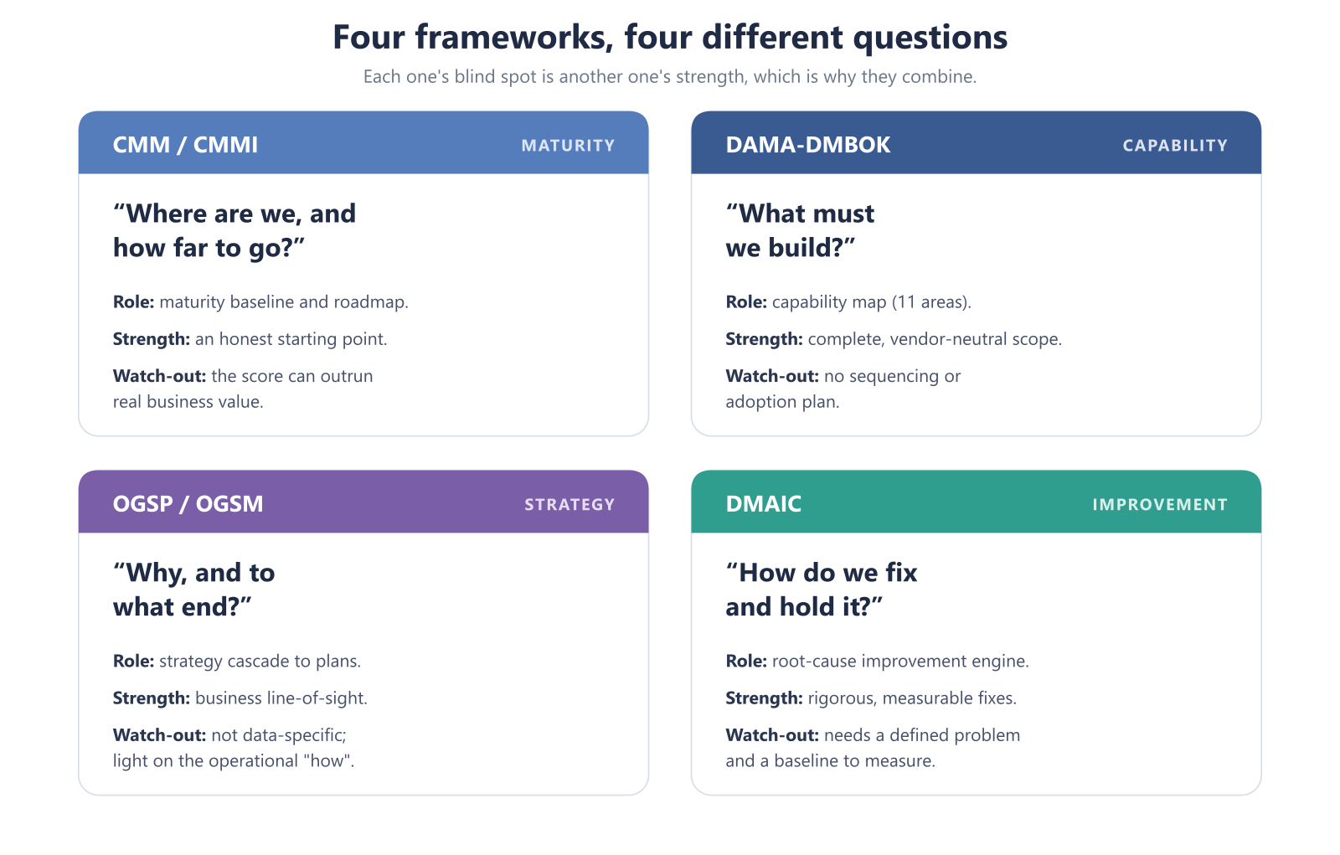
Figure 1. Each framework answers a different question, and each one's blind spot is another one's strength.

3.1 DMAIC - the improvement engine
What it is. DMAIC - Define, Measure, Analyze, Improve, Control - is the structured, data-driven problem-solving cycle at the core of Six Sigma. It was created by Motorola engineers in 1986 and popularized across industry by General Electric; today the American Society for Quality is its principal steward. Applied to governance, each phase maps cleanly onto a data problem: Define the systems, domains and failure in scope; Measure current data quality and integration performance; Analyze root causes with tools like 5-Whys and fishbone diagrams; Improve with targeted controls, definitions and ownership; and Control through scorecards, monitoring and an operating cadence that keeps the gain from eroding.
Pros.
- Rigorous and evidence-based: it forces root-cause analysis instead of symptom-treating, and it quantifies the before and after.
- Superb for concrete, bounded problems - a broken integration, a duplicate-record epidemic, a report no one trusts.
- Instantly familiar in any organization with a Lean or Six Sigma culture, which lowers the education cost to near zero.
- Its Control phase is a built-in answer to the "month four" decay problem.
Cons.
- It is problem-centric, not capability-building. DMAIC fixes what you point it at; it will not, on its own, tell you which governance capabilities an enterprise needs or stand up an operating model.
- It presumes a defined problem and a measurable baseline - hard to satisfy in an immature environment where the data to measure the data doesn't yet exist.
- Its manufacturing heritage can feel alien to business stakeholders, raising resistance if not translated into their language.
- Cyclical and project-shaped by nature, it needs a permanent governance home or it produces a series of one-off wins that never compound.

3.2 DAMA-DMBOK - the capability map
What it is. The DAMA-DMBOK (Data Management Body of Knowledge), maintained by DAMA International, is the profession's authoritative reference for what comprehensive data management contains. Its second edition organizes the field into eleven knowledge areas - governance, architecture, modeling and design, storage and operations, security, integration and interoperability, document and content management, reference and master data, data warehousing and business intelligence, metadata, and data quality - with Data Governance depicted at the hub of the "DAMA wheel," coordinating all the others. A third edition is in development to address AI and modern cloud architectures.
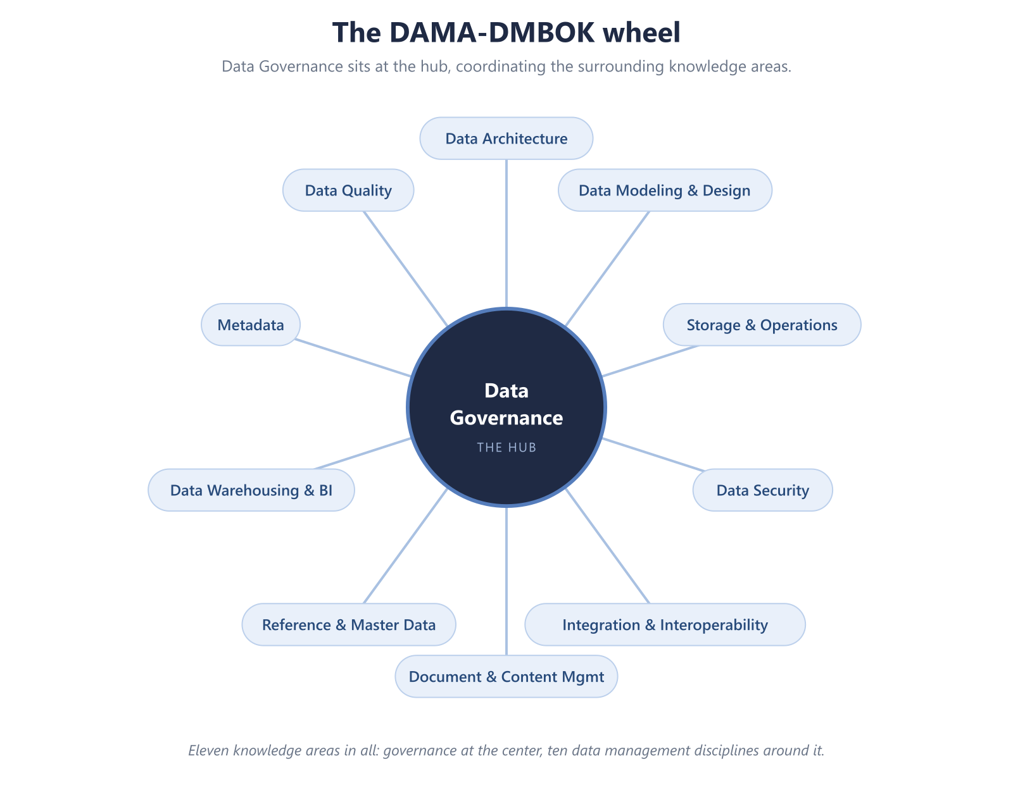
Figure 2. The DAMA-DMBOK wheel: Data Governance at the hub of the eleven knowledge areas.
Pros.
- Comprehensive and vendor-neutral: the definitive checklist of what a mature data program should include, and an excellent scope and gap-analysis tool.
- Establishes a shared professional vocabulary, which reduces cross-team miscommunication.
- Governance-centric by design - it treats governance as the coordinating discipline rather than one function among many.
- Academically defensible and widely recognized, which helps with audits and executive credibility.
Cons.
- It is a body of knowledge, not an implementation method. It describes the destination in exhaustive detail but offers no sequencing, no prioritization, and no maturity ladder.
- Its very comprehensiveness is a trap: hundreds of pages invite organizations to attempt everything at once and drown.
- It says little about change management - the human adoption problem that actually sinks most programs.
- Used literally, it can produce a beautiful capability inventory that never turns into a working program. As the saying in the field goes, DMBOK isn't a program; it's what a program is measured against.

3.3 OGSP - the strategy cascade
What it is. OGSP - Objectives, Goals, Strategies, Plans (some variants use "Projects," and the widely documented parent framework, OGSM, uses "Measures") - is a strategic-planning framework that cascades a long-term vision down to concrete, owned, time-bound action. Its roots trace to post-war Japanese quality management, and it was modernized and popularized at Procter & Gamble under CEO A.G. Lafley as a way to align a global enterprise around a single page of strategy. Applied to governance, it forces every initiative to answer four questions in order: Objective (where are we headed?), Goals (how will we measure success?), Strategies (how will we get there?), and Plans (what exactly will we do, and who owns it?).
Pros.
- Strategy-first: it ties every governance activity to a measurable business outcome, which is the single most reliable defense against budget cuts.
- Executive-friendly and communicable - the discipline of fitting strategy on one page creates alignment that dense frameworks never achieve.
- Cascades cleanly from enterprise vision to team-level plans, enabling portfolio management of governance initiatives.
- Excellent for buy-in: leaders fund what they can see themselves in.
Cons.
- It is a generic strategy tool, not a data framework. It will not tell you which governance capabilities to build or how to assess maturity - you must supply that content from elsewhere.
- It is light on operational "how": OGSP sets direction but leaves the week-to-week workflows to other methods.
- Its value depends entirely on the quality of the goals and metrics chosen; vague goals produce a tidy artifact and no traction.
- Without regular refresh, the one-page plan drifts from reality and becomes a poster rather than a management tool.

3.4 CMM / CMMI - the maturity ladder
What it is. The Capability Maturity Model, originally developed at the Software Engineering Institute at Carnegie Mellon (initially to assess U.S. Department of Defense software contractors) and now stewarded by ISACA as CMMI, grades an organization's processes across five levels: Initial (ad hoc), Managed (repeatable), Defined (standardized), Quantitatively Managed (measured), and Optimizing (continuously improving). Adapted to data governance, a CMM assessment scores current-state capability across governance dimensions, establishes a baseline, and lays out a roadmap for climbing from one level to the next. Notably, ISACA's CMMI v3.0 (2023) added a dedicated Data Management domain, reflecting how central data has become to organizational capability.
Pros.
- Diagnostic and directional: it tells you honestly where you stand and gives a clear ladder to climb, which is invaluable for baselining and for tracking progress over time.
- Benchmarkable - against your own past and, roughly, against industry norms.
- An excellent executive communication device: "we moved from Level 2 to Level 3" is a progress story leaders understand.
- Incremental by design, which suits governance's reality as a multi-year journey rather than a one-time build.
Cons.
- It is descriptive, not prescriptive about specifics: it tells you your level, not exactly which policy to write on Monday.
- It can degrade into "level chasing" - optimizing for the score rather than for business value, so that maturity rises while trust does not.
- Assessment quality depends on candor; self-scoring invites optimism.
- It neither fixes root causes nor aligns work to strategy on its own - it measures the journey but does not drive it.

4. Similarities and Differences
Beneath their different vocabularies, the four frameworks share a surprising amount. All four are structured, repeatable, and improvement-oriented. All four assume governance is an ongoing capability, not a one-off. All four are measurement-friendly and adaptable to an organization's context. And all four, in their mature use, insist that governance must serve the business rather than exist for its own sake. This shared DNA is why they combine so well.
The differences are best understood not as competing answers to the same question, but as answers to different questions:
Dimension | DMAIC | DAMA-DMBOK | OGSP | CMM / CMMI
Primary orientation | Problem-solving | Capability reference | Strategic alignment | Maturity measurement
Core question | How do we fix and hold this? | What must we build? | Why, and to what end? | Where are we on the journey?
Unit of work | An improvement project | A knowledge area | A strategy → plan | A maturity level
Time horizon | Weeks to months | Ongoing / reference | 1-5 years, cascading | Multi-year, incremental
What it measures | Defect / process metrics | Coverage of capabilities | Progress to business goals | Process maturity level
Greatest strength | Rigorous root-cause fixes | Completeness of scope | Business line-of-sight | Honest baseline + roadmap
Characteristic blind spot | Doesn't define scope or strategy | No sequencing or adoption plan | Not data-specific; light on "how" | Score can outrun real value

Read that table one column at a time and the complementarity is obvious. DMAIC is strong exactly where CMM is weak (it fixes things, where CMM only scores them). DAMA-DMBOK is strong exactly where OGSP is weak (it supplies the data-specific content OGSP lacks). OGSP is strong exactly where DMBOK is weak (it prioritizes and aligns what DMBOK merely lists). Each framework's blind spot is another framework's strength - which is the entire argument for combining them.

5. How to Choose
If you must lead with one framework - and most organizations should, to avoid overwhelming themselves - the right starting point depends on four factors.
1. Do you already run Six Sigma or a Lean/continuous-improvement program? If quality methods are already in your organization's bloodstream, DMAIC is the path of least resistance. Your people already speak it, your leaders already trust it, and governance framed as "a DMAIC project on our data" will clear cultural hurdles that a new vocabulary would raise. Lead with DMAIC and borrow DMBOK for scope.
2. What project and delivery methodology do you already use? Governance has to plug into how work actually gets delivered. If you run a formal portfolio/PMO discipline or strategy-cascade culture, OGSP maps naturally onto it and gives governance a strategic home. If you deliver in problem-focused increments, DMAIC slots in as your improvement engine. The goal is to ride existing rails, not lay new ones.
3. How mature and data-literate is your organization? Maturity should set your entry point. A low-maturity organization should start by finding out where it stands - a CMM assessment - paired with a lightweight OGSP to pick two or three goals, before attempting the full DMBOK. A high-maturity organization can go straight to DMBOK depth and DMAIC rigor, using CMM's upper levels (quantitatively managed, optimizing) to stay honest. Handing a 600-page body of knowledge to a Level 1 organization is the most common way to guarantee paralysis.
4. How easily can you educate and win buy-in? Match the framework to the audience you most need to convince. Executives respond to OGSP (business outcomes on a page) and to CMM (a progress scorecard). Quality-trained staff respond to DMAIC. Data professionals respond to DMBOK. The framework you can teach fastest is often the framework you should start with, regardless of its theoretical completeness.
The matrix below distills these factors into a starting recommendation:
If this describes you… | Start with | Then layer in
Established Six Sigma / Lean culture | DMAIC | DMBOK for scope; CMM to baseline
Strong strategy/PMO cascade; exec-driven | OGSP | DMBOK for content; DMAIC to execute
Low maturity; unsure where you stand | CMM (assessment) | OGSP for focus; DMBOK-lite for scope
High maturity; mature data team | DAMA-DMBOK | DMAIC for rigor; CMM L4-5 to sustain
Need executive funding above all | OGSP + CMM | DMBOK + DMAIC once funded

None of these is a permanent choice. The starting framework is simply the on-ramp; a healthy program adds the others as it matures.

6. The Meta4Data Recommendation: A Layered Hybrid
Choosing a single framework forces a false trade-off, because each one is missing precisely what another supplies. The stronger move - and the one we recommend for most enterprises - is to run them as four cooperating layers, each doing the job it is best at:
- CMM tells you where you are. Begin with a maturity assessment to establish an honest baseline and a shared picture of the gaps. This is your odometer and your roadmap.
- DAMA-DMBOK tells you what to build. Use the eleven knowledge areas to scope the capabilities the assessment says you're missing - but prioritized, never all at once.
- OGSP keeps it tied to the business. Cascade a small set of objectives, goals and strategies so that every capability you build traces back to an outcome an executive cares about and will fund.
- DMAIC keeps it improving. Run the specific fixes - the duplicate records, the broken integrations, the untrusted reports - as disciplined improvement cycles, and use the Control phase to make governance a standing operation rather than a launch.
Layered this way, the frameworks reinforce each other: CMM defines where you're going, DMBOK defines what you need to build, OGSP ensures the work serves the business, and DMAIC ensures it keeps getting better. The maturity model provides the trajectory, the body of knowledge provides the content, the strategy cascade provides the alignment, and the improvement engine provides the momentum. For a large, multi-year governance transformation - where executive accountability and demonstrable value are non-negotiable - this integrated approach is consistently stronger than any single methodology used in isolation.
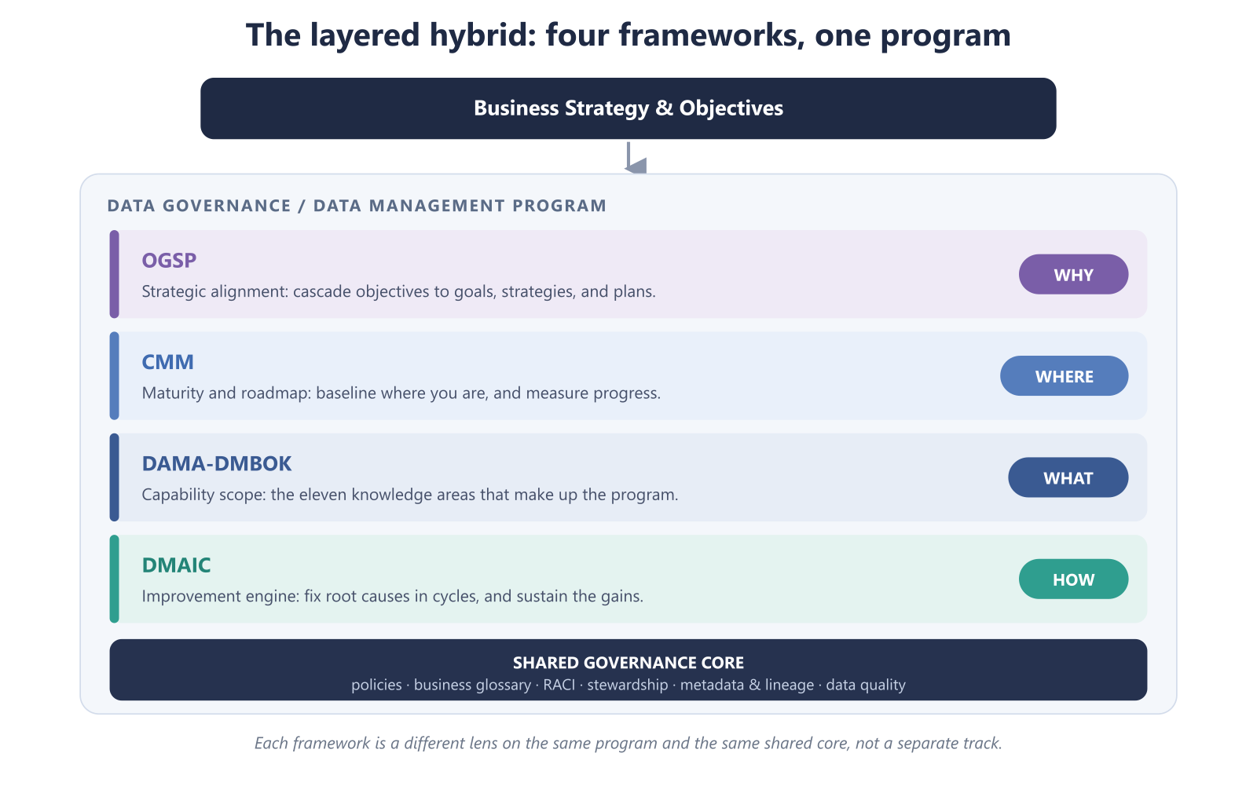
Figure 3. The layered hybrid: each framework is a different lens on the same program and the same shared core.
A practical sequence for most organizations looks like this: assess (CMM) → align (OGSP: pick a few objectives) → scope (DMBOK: choose the capabilities those objectives require) → improve (DMAIC: build and fix in disciplined increments) → sustain and re-assess (Control, then a fresh CMM cycle). The loop then repeats, at a higher level each time - which is, not coincidentally, exactly what "optimizing" maturity looks like.
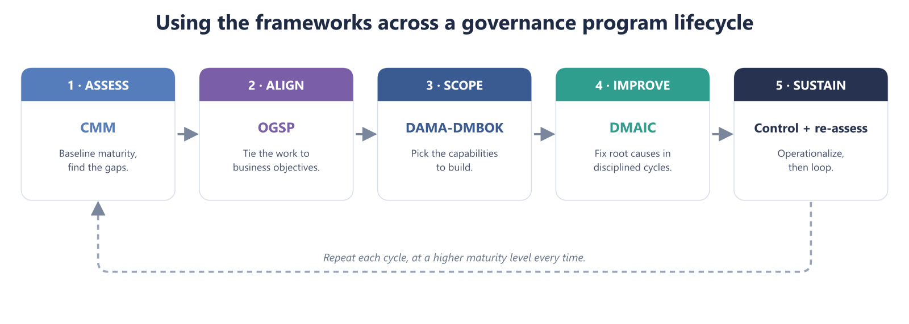
Figure 4. The same sequence as a repeating lifecycle: assess, align, scope, improve, sustain, then loop at a higher maturity level.

7. Conclusion
The frameworks debate is usually framed as a contest - DMAIC versus DAMA versus OGSP versus CMM - and that framing is the mistake. They are not rivals; they are instruments in a section, each tuned to a different part of the score. The organizations that struggle are the ones that grab a single instrument and expect a symphony. The organizations that succeed understand what each one is for, lead with the one their culture and maturity can absorb, and add the others deliberately as the program grows.
Know where you stand, know what to build, keep it tied to the business, and never stop improving it. No single framework does all four. Used together, they do.
Start by knowing where you stand. Meta4Data's Data Governance Maturity Survey is a CMM-based assessment that scores your program across nine dimensions and returns a tailored report of your gaps and a prioritized path forward - the honest baseline that every one of these frameworks depends on.
Then build the muscle, not just the binder. Meta4Data helps organizations turn the assessment into a working program: DMBOK-scoped capabilities, OGSP-aligned to your business objectives, and improved through disciplined DMAIC cycles - with the mentoring and education that make governance stick. Talk to us about an assessment, a roadmap, or a framework-selection workshop for your team.

Sources
- American Society for Quality (ASQ), _DMAIC Process: Define, Measure, Analyze, Improve, Control_ - asq.org/quality-resources/dmaic.
- American Society for Quality (ASQ), _What Is Six Sigma?_ - asq.org/quality-resources/six-sigma.
- DAMA International, _DAMA-DMBOK: Data Management Body of Knowledge_ - dama.org.
- Snowflake, _DAMA-DMBOK Explained: The Data Management Framework_ - snowflake.com/en/data-governance/frameworks/dama-dmbok.
- Dataversity, _What Is the Data Management Body of Knowledge (DMBOK)?_ - dataversity.net.
- ISACA, _CMMI (Capability Maturity Model Integration) Performance Solutions_ - isaca.org/enterprise/cmmi-performance-solutions.
- _Capability Maturity Model Integration_ - overview and history - en.wikipedia.org/wiki/Capability_Maturity_Model_Integration.
- _OGSM (Objectives, Goals, Strategies, Measures)_ - framework and origins - en.wikipedia.org/wiki/OGSM.

